Guidelines on Risk Appetite Practices for Banks

April, 2018

Contents
I. Introduction 4
A. Context of the Guidelines 4
B. Objectives of the Guidelines and Key Principles for RAF Supervisory Assessment 5
C. Definitions 7
II. Guidance 11
A. Governance and Process 11
i. RAP, Risk Management Strategy, and Business Strategy 11
ii. Preparing, Reviewing, and Reporting the RAS 14
iii. RAFs in a Group Context 16
iv. RAF Governance and Proportionality 17
B. Content and Metrics 19
i. Relationship of the RAF with the ICAAP/ILAAP and the Recovery Plan 19
ii. Elements of the RAF 20
iii. Risk Categories and Comprehensiveness of the RAF 24
iv. RAP Metrics and Proportionality 26
C. Embedding and Cascading 27
i. Cascading and Escalation 27
ii. Embedding: Communication, Training, and Risk Culture 30
iii. Embedding: Remuneration 32
iv. External Communication 32
v. Embedding of the RAF and Proportionality 34

List of Acronyms

Bank of Slovenia (BoS)
Bank of Slovenia Regulation on Internal Governance Arrangements, the Management Body and the Internal Capital Adequacy Assessment Process for Banks and Savings Banks (BoS Regulation on Internal Governance Arrangements)
Chief Risk Officer (CRO)
European Banking Authority (EBA)
EBA Internal Governance Guidelines (EBA Governance Guidelines)
European Bank for Reconstruction and Development (EBRD)
European Central Bank (ECB)
European Commission (EC)
Financial Stability Board (FSB)
National Competent Authority (NCA)
Internal Capital Adequacy Assessment Process (ICAAP)
Internal Liquidity Adequacy Assessment Process (ILAAP)
Less Significant Institution (LSI)
Liquidity Coverage Ratio (LCR)
Management Board (MgmtB)
Management Information System (MIS)
National Competent Authority (NCA)
Risk Appetite (RAP)
Risk Appetite Framework (RAF)
Risk Appetite Statement (RAS)
Risk-Weighted Assets (RWA)
Significant Institution (SI)
Single Supervisory Mechanism (SSM)
Slovenian Banking Act of 2015 (Banking Act)
SSM Supervisory Statement on Governance and Risk Appetite (SSM Supervisory Statement)
Supervisory Review and Evaluation Process (SREP)
Supervisory Board (SB)
Supervisory Board Risk Committee (SBRC)
- Introduction
  - Context of the Guidelines
- These guidelines were developed as part of a project to enhance supervisory and commercial practices in the area of risk appetite (RAP) and risk appetite frameworks (RAFs) in Slovenia. The project is led by Nestor Advisors Ltd., a London-based consultancy exclusively focused on corporate governance and organisational design in the financial sector, and supported by the European Bank for Reconstruction and Development (EBRD) and the Structural Reform Support Service of the European Commission (EC).
- The three main project deliverables are:
  - A report describing best supervisory practices related to assessing RAFs and best RAP practices in selected EU banks (the report);
  - Guidelines on RAP practices for banks (the guidelines); and
  - Training for the BoS and Slovenian banks on the guidelines.
- The guidelines are designed to be as practicable as possible and include examples of good and bad practices to provide detailed and actionable guidance to banks. The guidance is based upon the report, which was delivered and presented to the project stakeholders in December 2017, and on subsequent discussions among the project stakeholders. The report includes detailed reviews of:
  - The relevant Slovenian regulations and approach by the BoS;
  - RAF practices of a representative sample of six Slovenian banks;
  - Best supervisory practices and expectations related to RAFs in the EU and beyond. The EU supervisory context was at the heart of this section, because Slovenia’s banking sector is closely integrated into the EU’s common institutional architecture (as a member of the Eurozone and a participant in the SSM); and
  - Best RAF practices across a representative sample of six European banks.
- Because of Slovenia’s membership of the Eurozone, the guidelines are designed to reflect existing SSM guidance and practice regarding RAFs. The guidelines take as their starting point the recommendations in the report that aim to help banks improve their RAP-related practices. Given the important link between the guidelines and the recommendations, the guidelines should be considered in conjunction with the findings in the report.
- The guidelines are structured around three distinct areas:
  - Governance and Process; covering the relationship between the RAF and business strategy, the role of different internal stakeholders in the development and implementation of RAFs, and RAFs in a group context;
  - Content and Metrics; covering the relationship between the RAF, the Internal Capital Adequacy Assessment Process (ICAAP), the Internal Liquidity Adequacy Assessment Process (ILAAP), the definition and importance of risk capacity, the different quantitative and qualitative elements of the Risk Appetite Statement (RAS), and the “dashboard”; and
  - Embedding and Cascading; covering the cascading of RAP thresholds and limits throughout the bank, escalation in case of breaches, training and other embedding mechanisms, RAP-related remuneration matters, and external communications related to RAP.
- Proportionality is an important element in every supervisory approach under Pillar 2 of the Basel Framework. In order to ensure the guidelines are actionable and useful to all Slovenian banks - including both SIs and LSIs - we also discuss specific questions of proportionality in each of the three areas and give examples where appropriate.
- It is also important to stress that the Slovenian legal framework provides for both dual and unitary board structures. Under the dual board system, there are two separate boards: the Management Board (MgmtB) responsible for daily management of the business and executing the bank’s strategy; and the Supervisory Board (SB) responsible for setting the bank’s strategy as well as overseeing management. By contrast, under the unitary board system, there is only one Board of Directors generally composed of both executive and non-executive Directors.
- The CRD IV framework generally refers to the “management body” of a bank to cover both dual and unitary board structures. Based on the prevalence of the dual board system in the sample of Slovenian banks that participated in the drafting of the report, the guidelines generally refer to the SB as the body charged with setting the bank’s strategy as well as overseeing management. However, it is important to note that the guidelines cover both systems. This approach is aligned with the SSM Supervisory Statement on Governance and Risk Appetite (SSM Supervisory Statement) and with the EBA’s Internal Governance Guidelines (EBA Governance Guidelines).
  - Objectives of the Guidelines and Key Principles for RAF Supervisory Assessment
- RAFs are part of the Basel Pillar 2 toolkit. As such, their development is and should remain the primary responsibility of individual banks. Hence, the guidelines do not articulate specific supervisory expectations. They are rather aimed at helping Slovenian banks develop effective frameworks tailored to their strategic needs and individual capacities. The task at hand was to distil best practice by banks and their supervisors into a set of normative statements (followed by a more detailed explanation and examples) that can be used by individual banks to tailor their RAF and RAS.
- However, there is a set of underlying principles that underpin these guidelines and, from the BoS’ perspective, will frame the supervisory assessment of RAFs in Slovenian banks. These principles conform with Slovenian legislation but also closely mirror relevant supervisory expectations of the SSM as well as additional regulatory guidance, notably from the EBA.
- The key underlying principles are summarised below as a set of general expectations. Well-developed RAFs should provide:
  - Strategic and tactical tools for defining the levels of risk banks are willing to assume in pursuit of their strategy and when operationalising their business objectives;
  - A platform for addressing all material risks taken, at the level of the bank as a whole as well as for different business lines;
  - A mechanism to engage the Supervisory Board (SB) in developing a risk-conscious strategy and in capital planning and allocation;
  - A mechanism to engage management at every level of the bank in implementing the bank’s risk-conscious strategy;
  - The ability to measure, monitor, and adjust as necessary the actual risk positions against the established RAP; and
  - A foundation for communication among internal and, as necessary, external stakeholders, promoting a shared risk language and fostering a common risk culture.
- Based on these principles, the BoS expects Slovenian banks to always be prepared to respond to the following queries:
  - Does a RAF exist? Is the documentation complete, comprehensive, and coherent?
  - Is the RAF evolving? Is it regularly reviewed and adjusted to the changing business environment and the bank's business strategy?
  - Is there evidence of robust challenge of the RAF by the bank’s management and supervisory function?
  - Is the RAF embedded within the bank, rather than simply "announced"?
  - Is the RAF effective in guiding the everyday running of the bank and key decision-making processes, including selling existing products, introducing existing products to new customer segments, approving new products, concluding outsourcing agreements, or pursuing M&A?
- Banks should be ready to provide memorialised evidence regarding the points listed above.
  - Definitions
- In the interest of providing actionable and practical guidelines, and to avoid confusion, the most important definitions used throughout the present document are listed below. They are based on the FSB’s Principles for An Effective Risk Appetite Framework and the CRD IV framework , with minor additions to cover all elements of the project:
Bank:
A credit institution as defined in point (1) of Article 4(1) of Regulation (EU) No 575/2013: an undertaking the business of which is to take deposits or other repayable funds from the public and to grant credits for its own account.
Risk Culture:
A bank’s norms, attitudes and behaviours related to risk awareness, risk-taking and risk management, that shape decisions on risks.
Risk Appetite (RAP):
The aggregate level and types of risk a bank is willing to assume within its risk capacity to achieve its strategic objectives and business plan.
Risk Capacity:
The maximum level of risk the bank can assume given its current level of resources before breaching constraints determined by regulatory capital and liquidity needs, the operational environment (e.g. technical infrastructure, risk management capabilities, expertise) and its obligations to depositors, policyholders, shareholders, fixed income investors, as well as other customers and other stakeholders.
Risk Appetite Framework (RAF):
The overall approach (including policies, processes, controls, and systems) through which risk appetite is established, communicated, and monitored. It includes a risk appetite statement, risk thresholds and limits, and an outline of the roles and responsibilities of those overseeing the implementation and monitoring of the RAF. The RAF should consider material risks to the bank, as well as to the bank’s reputation vis-à-vis policyholders, depositors, investors and customers. It is reviewed regularly.
Risk Appetite Statement (RAS):
The written form of a bank’s risk appetite. It includes qualitative statements as well as quantitative measures expressed relative to earnings, capital, risk measures, liquidity and other relevant measures as appropriate. It should also address risks which are more difficult to quantify such as reputational risks, cyber and conduct risks, as well as money laundering and unethical practices. It is set on an annual basis.
Risk Profile:
A point in time assessment of the bank’s gross and, as appropriate, net risk exposures (after taking into account any mitigating factors) aggregated within and across each relevant risk category based on forward looking assumptions.
- We also define some additional concepts that are central to our discussion:
RAP Thresholds :
RAP thresholds are situated at the portfolio level and set the level of RAP the bank wants to assume with respect to a given (often a relatively broad) aggregation of assets. Depending upon the size and scope of the portfolio, one can further differentiate between mid-level and high-level portfolio thresholds.
RAP thresholds are based on a firm-wide view of RAP and contain more granular guidance for specific portfolios (top-down perspective). The design of certain thresholds should also reflect feedback from the concerned business units on whether they are set at the right level (bottom-up perspective). RAP thresholds should be based on regular internal stress tests performed both at the institution-wide and the sub-consolidated level. The results should feed into the regular review of the RAF and RAS.
When the risk profile of the given portfolio comes close to threshold levels, a red flag should be raised all the way to the top of the bank. Management then needs to immediately take remedial action such as limiting the threshold business/activity.
The most important high-level thresholds are generally those that are included in the institution-wide RAS and hence in the dashboard used by the SB to monitor the institution-wide RAP and risk profile.
RAP Limits:
RAP limits set the level of RAP either for a given (often relatively small) portfolio or for specific transactions. In contrast to RAP thresholds, RAP limits create binding business constraints to front line personnel and to credit committees. Transactions in breach of limits have to be approved by the escalation authority.
RAP limits are set from a top-down perspective and should also reflect feedback from the relevant business units (bottom-up perspective). Like RAP thresholds, RAP limits should be based on regular internal stress testing.
Risk Tolerance:
Maximum negative impact (loss amount) a bank is willing to accept from a specific risk event or series of risk events. While often used interchangeably with RAP, we use the term to describe RAP in non-business areas such as operational/reputational risk.
Management Body:
According to Article 3 (1) (7) of Directive 2013/36/EU, an institution's body or bodies, which are appointed in accordance with national law, which are empowered to set the institution's strategy, objectives and overall direction, and which oversee and monitor management decision-making, and include the persons who effectively direct the business of the institution.
Management Board:
Under the dual board system, there are two separate boards including the Management Board (MgmtB) and the Supervisory Board (SB). The MgmtB is responsible for daily management of the business and executing the bank’s strategy.
Supervisory Board:
Under the dual board system, the Supervisory Board (SB) is responsible for setting the bank’s strategy as well as overseeing management.
Senior Management:
Based on Article 7, paragraph 1, item 30 of the Slovenian Banking Act of 2015, the term senior management refers to the management level just below the Management Board (B-1).
Credit Authorities:
- Constraints on transaction approvals contained in banks’ credit manuals (sometimes also referred to as “risk limits”). They are different from RAP limits and establish the approval (escalation) mechanisms for specific types of transactions in a product or business setting. They are reviewed occasionally and separately from RAP.
- For instance, a bank might determine that consumer loans below EUR 20,000 can be approved at the level of the branch manager, subject to a risk assessment.
It is important to note that these credit authorities are not part of the RAF. However, banks should ensure that RAP thresholds and limits take into account existing credit authorities, so that the RAF does not undermine the procedures in the credit manual or vice versa. Sometimes an important change in RAP might trigger a review of a bank’s credit authorities.

- Guidance
  - Governance and Process
    - RAP, Risk Management Strategy, and Business Strategy
      - Guidelines
1. The bank should explicitly link the development of the RAF to the budget process and annual business strategy review, taking into account the bank’s strategic objectives and multi-year strategy plan. In particular, there should be close alignment and coordination between the annual budget and RAS approval processes.
2. RAF is primarily a top-down process and should be owned by the very top of the bank. In the case of a two-tier board structure, the bank should assign clear responsibility to the SB for setting the bank’s RAP, approving its RAS and ensuring that RAP is aligned with the overall multi-year business strategy. The MgmtB needs to work with the risk management function to develop the RAP and RAS before the draft documentation is submitted to the SB for approval.
      - Discussion
- The RAF is a crucial tool for defining and executing a bank’s business strategy. By setting RAP thresholds and limits across business lines and defining processes for managing them, it allows the people in charge of setting a bank’s business strategy to oversee risk taking across the organisation as this strategy is implemented. The RAF should therefore be at the heart of a bank’s risk management framework and must inform and reflect the business objectives that a bank wants to achieve.
- The RAS, the budget, and the business strategy should all be reviewed annually. Banks need to ensure that these three processes work together seamlessly and that changes in one of the frameworks are appropriately reflected in the others. This includes a regular feedback loop between the aforementioned processes and close cooperation between the different teams involved. In particular, there should be close alignment and coordination between the annual budget and RAS processes, i.e. the budget should be based on existing RAS indicators and the annual review of the RAS should reflect existing budget constraints. It is also important to note that internal stress testing of different risk areas and risk indicators is a key component in developing mature RAFs.
- One way to link the strategy and budget processes on the one hand, to the RAP process on the other could consist of the following steps:
  - On the basis of MgmtB proposals the SB sets/reviews the bank’s long term strategic objectives taking into account the organisation’s current positioning in the market, its competences, culture, and aspirations;
  - Based on its current capabilities and level of resources the bank defines its risk capacity. This exercise is closely linked to the review of the recovery plan, as required by the BRRD.Ideally, a reverse stress test would be used to identify the events and risks that could jeopardise the bank’s continued operation.
  - With the bank’s risk capacity in mind, the SB reviews (or rolls over) the bank’s multi-year business plan.
  - This multi-year business plan is translated into annual budget(s) and the relevant allocation of capital.
  - The RAS is developed reflecting capital allocation and revenue targets in the budget, identifying appropriate RAP categories (“buckets”) and setting thresholds and limits that all lie within the bank’s risk capacity.
- The steps described in points 20.1 and 20.2 above are combined to set the outer perimeter of strategy and risk appetite. Steps 20.3 to 20.5 provide the framework for the risk-return discussion that is at the core of setting bank-wide business targets and allocating capital. In practice these steps should be combined and taken simultaneously.
- It is also important to note that the SBRC (or the combined audit and risk committee) plays an important role in preparing and supporting the work of the whole SB in the area of risk appetite. The advisory role of the SBRC regarding the bank’s RAP (“propensity to assume risks”) and risk management strategy is spelled out in Article 51 of the Slovenian Banking Act of 2015. Article 49 of the same act stipulates that the members of the SBRC should have “the requisite knowledge, skills and experience” to understand and monitor the bank’s risk management strategy and RAP.
- The following graph A further illustrates the approach outlined above:

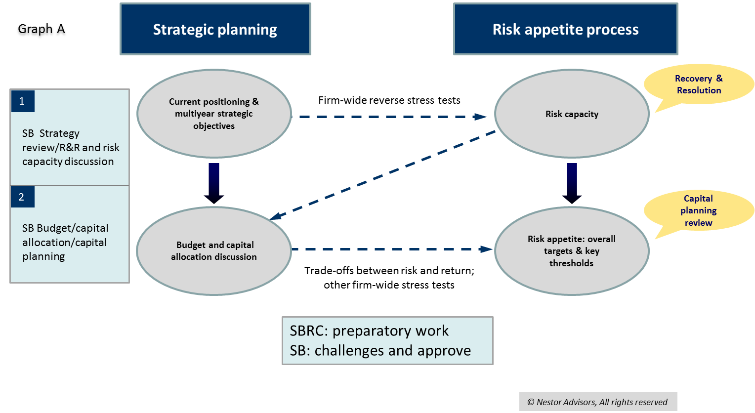

Case Box 1
Bank A sets the budget for the coming year towards the end of the current year. The budget forecasts for the coming year reflect the RAP levels and limits contained in the RAS for the current year. Based on these budget forecasts the annual review of the RAS starts in Q1 of the year ahead.
This approach is different from the example described above: it discusses RAP and budgets at different stages and creates a sequential circle of adjustment of both processes. If efficiently executed, it could be as effective as the approach described in the text above.
    - Preparing, Reviewing, and Reporting the RAS
      - Guidelines
3. The RAF should have a formal and transparent governance structure. There should be clear roles for all internal stakeholders i.e. the risk management function, senior management, the MgmtB, the SBRC, and the SB. In particular, the bank needs to be able to demonstrate that the SB and the SBRC are fully engaged in the RAF development process by actively challenging assumptions and recommendations made by the risk management function and senior management.
4. RAF should promote in-depth discussions and challenge among the stakeholders at every level regarding RAF assumptions, design, metrics, and implementation.
5. The internal stakeholders should monitor the bank’s risk profile and RAF implementation through the use of comprehensive and user-friendly dashboards on a regular basis. At the SB and SBRC level, the dashboard should cover no more than 15 main risk indicators based on the bank’s (and group’s) material risk areas or businesses.
6. The RAS should be a dynamic, living document that is periodically, at least annually, calibrated, in particular with respect to RAP limits and capital allocation. When the RAS is changed, this should be well documented for third parties to understand the cause and rationale.
      - Discussion
- A well-developed RAF should have a formal and transparent governance structure. Some banks document this structure and process in their ICAAP/ILAAP documentation while others have a stand-alone policy. The governance arrangements should include clear roles for all the stakeholders involved at every level of the bank, i.e. the SB, the MgmtB, senior management, business units, the risk management function, and internal audit.
- While the RAF should be discussed, approved, and owned by the very top of the bank and its implementation should be based on a top-down approach, its development should also include significant bottom-up inputs from various other stakeholders to ensure the RAF is comprehensive and effectively implemented.
- The risk management function should have primary responsibility for developing the RAF and the first draft of RAS, in close cooperation with the bank’s business units, while maintaining an open discussion with the SBRC on RAP’s main elements. The MgmtB should have a clear role and “ownership” in the shaping of the RAF/RAS and challenge the risk management function before discussion of the RAF (i.e. the policy document) and RAS by the SBRC.
- In particular, the SB should take the primary role in the final definition, approval, and active monitoring of a bank’s RAP and risk profile. The SB and SBRC should actively challenge the MgmtB and risk management function on the design of the RAF, its content, and on specific RAP limits.
- An appropriate division of labour between the SB and the SBRC helps ensure that the two bodies are fully engaged on matters of RAP. The SBRC should include banking experts, ideally risk specialists, who do the “heavy lifting” in guiding the risk management function, challenging the MgmtB (and risk management function, once the RAS is presented) and keep the SB informed. The latter would then provide for a further layer of challenge in the context of strategic and budget reviews, as discussed above.
- Furthermore, the internal audit function should conduct regular (ideally annual) independent reviews of the RAF’s design and effectiveness, based on its risk-based audit plan.
- These multi-layered discussions and challenges between different internal stakeholders are not only important for developing a comprehensive RAF and RAS. They are also important for embedding the RAF throughout the bank and are an essential generator of a shared risk culture, a key element of sound risk management and, as such, a critical supervisory imperative.
- Adequately minuting RAP discussions is another element of good governance that is expected by supervisors. The largest banks might therefore want to consider dedicated secretariats (within the broader board secretariat function) for the SBRC, also supporting risk related discussion at plenary SB meetings.
- Regularly monitoring performance and risk profiles against a “dashboard” of RAS metrics throughout the period is a critical element of good RAP governance. The dashboard should be user-friendly and suitable for members of the SB and the SBRC with different skills and backgrounds. At that level it should be as self-explanatory and self-sufficient as possible and the level of granularity should match the RAS and the business plan.
- The risk indicators included in the dashboard should be tailored to the size and complexity of the bank and cover all material risks, ideally with multiple indicators used to capture each type of material risk. In any event the SBRC should see on a regular basis (at least four times per year) the difference between current risk profile levels and the RAS thresholds and limits. Special focus and challenge should be reserved for threshold breaches or near breaches. Qualitative indicators should also be the object of discussion and relevant information should be provided by the risk management function.
- The SBRC should understand and query these levels and give guidance to management on appropriately steering the bank’s risk profile.
- To ensure the dashboard’s usefulness to all RAP stakeholders, the metrics and types of information measured could vary at different levels of the organisation. For example, many MgmtBs or management level risk committees might see much more granular dashboards with more detailed information compared to the SB level. At the SB level, the information included should be sufficiently aggregated and banks should aim for a limited number of individual risk indicators to ensure clarity and usefulness of the information. The total number of risk indicators in the dashboard should therefore not exceed 15 at the SB level.
Case Box 2
The risk management function of Bank B prepared the RAS and the RAF while working directly with the CRO, the MgmtB, and the SB. The draft documentation was then presented to the SBRC. After submitting initial versions, the bank went through multiple drafts of the RAF documentation based on robust discussions between the risk management function, the CRO, and the SBRC. After some iterations, the SBRC signed off on the RAF and the RAS and the documents were subsequently approved by the full SB.
Clearly, RAF and RAS were adequately challenged in a manner that ensured “ownership” by all stakeholders.
    - RAFs in a Group Context
      - Guidelines
7. In principle, the RAF should be group-wide rather than entity specific. As the RAF is rolled out towards various group entities it should allow for localised strategic imperatives, risk profiles, and supervisory expectations that should be reflected in the RAS of significant group entities.
      - Discussion
- For RAFs to be effective in the context of cross-border groups, the parent should develop a general approach and risk framework for all subsidiaries. This approach reflects the parent company board’s overall responsibility for group strategy and internal governance towards its stakeholders and its supervisors, based on Article 108 of CRD IV. In some cases, the parent might also allow for variation of entity level RAFs, as long as they follow the same principles and are built on the same template, as illustrated in Case Box 3 below.
- Part of the group character of the RAF includes the responsibility of central functions for coordinating, reviewing, and validating risk bearing decisions of subsidiaries. These actions should be clearly documented in the group’s internal (group) governance policy and be available to both home and host supervisors.
- While RAFs should be consistent across the group, the development of the RAS at subsidiary level might differ. Different business circumstances, macroeconomic environments and country-specific risks need to be reflected in the local entity’s risk strategy and the types of risks it wants to assume to achieve its goals. A “localised” RAS should be reflected in the dashboard that informs decision making of the local entity’s SB. Conversely, the group’s RAF should allow subsidiary risks to be effectively reflected in the group’s risk profile.
- Guidance from the risk management function at group level is especially important in designing and implementing comprehensive RAFs. The group function needs to be close to the subsidiary functions and provide its active support in properly capturing financial and non-financial risk within the RAF and RAS. The group function should also ensure that local risk management functions have adequate resources needed to fulfil their local responsibilities. This may go as far as assisting in recruitment and training. Furthermore, the group should be active in sharing experience on RAF implementation across subsidiaries (including on past loss events or near misses).
Case Box 3
Bank C is part of a larger Eurozone banking group and receives RAF guidance from the parent bank in the form of a RAF template. The local bank is heavily focused on retail banking, which, however, is not a very important business for this bank’s parent who is more focused on corporate lending.
The group RAF template leaves a lot of flexibility for local entities to tailor their RAP documentation to the specific local business strategy. Bank C’s local risk management function has adapted the group template and has put the emphasis on the retail sector to appropriately capture the local strategy, activities, and associated risks. This tailored local approach is then integrated into the group reporting framework.

    - RAF Governance and Proportionality
- The questions related to RAF governance discussed in this section raise important proportionality issues. In the following paragraphs, we outline specific areas where our guidance may differ depending on the size and complexity of the bank.
- For bigger and more complex banks that can devote more resources to developing and updating their RAF governance, we would expect the processes to be included in a single, stand-alone policy. Smaller banks might reasonably choose to detail their RAF procedures in the relevant ICAAP/ILAAP documentation or risk management strategy – as long as the difference between the RAF and other processes is made clear.
- Ideally, the SB and SBRC should both actively challenge the MgmtB and risk management function on the design and content of the RAF and on specific RAP limits, in the sequence describes above. However, smaller banks may consolidate the layers of discussion and challenge at SB level in one iteration, bypassing the merged audit and risk committee.
- The largest banks should consider establishing dedicated secretariats within the broader board secretariat function for the SBRC which might also support discussions around RAP and other risk-related topics at plenary SB meetings. This support would cover the preparation and documenting of discussions and decisions taken. In smaller banks with fewer administrative resources, secretariat support in these areas might actually come from the risk management function itself. The risk management function should ensure adequate minuting of RAP-related discussions at the SB level.
- In the case of bigger and more complex banks the internal audit function might reasonably be expected to review the RAF on an annual basis. Although smaller banks should also have regular reviews by internal audit, they might choose to have longer intervals between individual reviews due to resource constraints.
- The design of RAP metrics included in the dashboard heavily depends on the complexity of the bank. For large and complex banks, the dashboard should include multiple indicators for each material risk area and also have metrics specific to one or more important business lines at the SB level. As will be discussed in the next chapter, smaller banks might choose simpler metrics that are focused on the whole firm without identifying any other sub-firm categories (“buckets”).

  - Content and Metrics
    - Relationship of the RAF with the ICAAP/ILAAP and the Recovery Plan
      - Guidelines
8. The bank should view the RAF as an independently articulated decision making and control system reflecting the bank’s business strategy. RAS should be the core of this articulation rather than a summary version of the bank’s ICAAP/ILAAP metrics and targets.
9. Notwithstanding Guideline 8, the RAF should be fully consistent and, ideally, directly linked to the ICAAP/ILAAP and recovery plan approaches and metrics. The concept of risk capacity might be central in this respect.
      - Discussion
- In our view, the RAF and the ICAAP/ILAAP are closely related but separate frameworks. While they both are grounded in risk, they differ in their purpose, direction, and scope, especially their temporal scope.
- A bank’s RAF should focus on drawing the perimeter around the overall business strategy and direction of the bank. It includes a set of business-related, forward-looking measures and metrics whose main purpose is to produce RAP thresholds and limits. High level thresholds and limits circumscribe the bank’s business portfolio(s) on an aggregate basis and are then cascaded within each one of the business lines and units through a system of ever more granular portfolio limits. The thresholds and limits and relevant escalation and reporting processes are a critical means of controlling the bank’s risk profile at any given time.
- ICAAP and ILAAP are much detailed in scope than the RAF. From a systemic perspective, their architecture is related to RAF. Internal capital and liquidity planning cannot be effective without linking to the risks that are inherent to the bank’s businesses strategy. The way the two processes are constructed needs to be consistent. RAF and ICAAP/ILAAP are different but need to be “joined at the hip”.
- At their heart, ICAAP/ILAAP provide a taxonomy of risk metrics that are used to calculate internal capital requirements calibrated to the current risk profile, thus ensuring the bank’s continuation as a going concern. These metrics are modelled on the Basel “risk canon”, including all risk areas included in Pillar 1 and Pillar 2 (e.g. credit risk, market risk, operational risk, liquidity risk, IRRBB, profitability risk, and reputational risk). This functional taxonomy is one-dimensional because of its single, all-important purpose: capital adequacy. However, the RAF requires a more dynamic view of risk that can accommodate the essentially forward-looking perspective of strategic business planning.
- It is as important to eventually “translate” RAF metrics into the ICAAP/ILAAP calculations as it is to inform the RAF process with the ICAAP/ILAAP results. However, RAF metrics need an added dimension that brings them closer to the actual business (and business plan) of the bank.
- In addition to consistency with and “hardwiring” into the ICAAP/ILAAP, the RAF needs to be consistent with recovery planning as mandated by the BRRD.
- According to relevant EBA guidance, scenarios underpinning the recovery plan should account for severe stress to the bank in the following areas: capital, liquidity, profitability, risk profile, operations, and reputation. For each stress scenario, the recovery plan has to establish appropriate triggers for the recovery process to take effect, i.e. “recovery indicators”.
- The RAF and recovery planning are both forward-looking, business-related, risk-based processes. As such, there is scope for significant coordination between them. From a supervisory perspective, consistency is expected across them and ICAAP/ILAAP in the context of the SREP. But coordination also makes sense from the bank’s perspective. Combining the process of reviewing and setting RAP with recovery planning, especially when it comes to adopting relevant firm-wide scenarios and setting mutually coherent relevant thresholds and triggers across the two frameworks, effectively promotes streamlined risk governance within the bank. While few banks seem to follow such an integrated approach today, banks should consider this going forward.
- In fact, the concept of risk capacity (i.e. the maximum level of risk a bank can assume given its current level of resources) is central to all the three frameworks that underpin bank solvency: RAF, ICAAP/ILAAP, and recovery planning. The need for consistency suggests that the definition of a bank’s risk capacity must serve as the link between the three frameworks and should therefore be coherent across them.
    - Elements of the RAF
      - Guidelines
10. The bank should establish a quantitative definition of its risk capacity, ideally expressed in capital terms.
11. The bank should establish an institution-wide RAP which should be within the general perimeter of its risk capacity. The RAP structure should be articulated through the RAS.
12. The RAS should also identify the key categories of risk related to the most important businesses of the bank (including, if relevant, legal entities or areas of activity) and the metrics or qualitative criteria for assessing risk levels in these areas.
13. The RAF should consist of the system of thresholds and limits established in each area and further cascaded within each business or area of activity.
14. The system of RAP thresholds and limits should be supported by regular stress testing at the institution-wide level.
      - Discussion
- The first step in developing a RAS is the definition of the bank’s risk capacity. The risk capacity should be understood as the “risk frontier”: the outer perimeter of the risk level that a bank can assume given operational and regulatory constraints, before its status as a going concern is challenged. The institution-wide RAP as articulated in the RAS must be situated well within this broader perimeter. In other words, there should be a buffer between the definition of the risk capacity and the total risk appetite of the bank. Therefore, the risk capacity (and the buffer) should be expressed in terms that can be compared to the metrics used for risk appetite. The concepts are illustrated in graph B below:
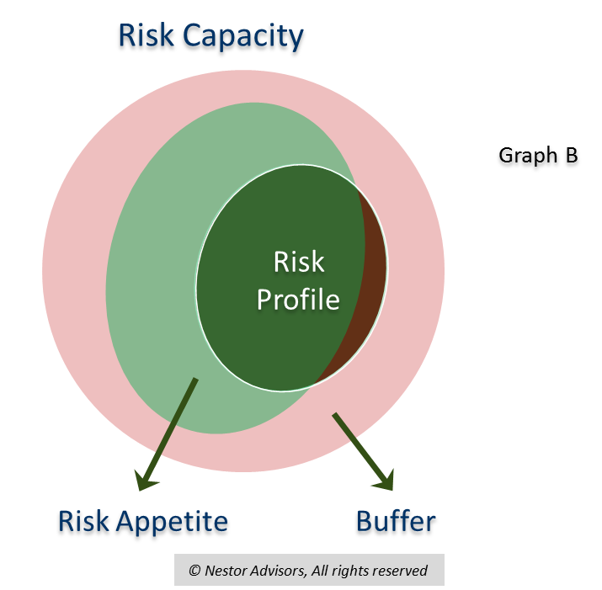
- Defining a bank’s risk capacity is a crucial step in developing a comprehensive and effective RAS. As noted above, it is also the area in which the concept of RAP connects directly with those of ICAAP/ILAAP and recovery planning. Therefore, risk capacity would ideally be calculated in terms of capital adequacy, although some banks might choose risk-weighted asset (RWA) levels to express it. A liquidity risk capacity is also important and many banks use regulatory stress-based metrics for this purpose such as LCR.
- Banks need to establish an adequate benchmark or “anchor” when calculating their risk capacity. While smaller banks might focus on regulatory Pillar 1 capital, it may be important for more complex banks to take into account ICAAP (internal) capital and/or supervisory Pillar 2 capital. ICAAP buffers might be considered either outside or within (as part of the RAP buffer) the risk appetite perimeter, depending on the way the bank decides to connect its RAF to the ICAAP.
- In any event, it is important that banks establish a clear definition of risk capacity in their RAFs that includes a description of the type of capital (Pillar 1 or Pillar 2) that they use as a basis for that definition.
- The RAS should articulate the structure of the RAF. This involves the following main steps (summarised in graph C below):
  - Definition of the bank’s risk capacity as discussed above.
  - Definition of the RAP categories (or “buckets”) and setting of high-level RAP thresholds in the RAS based on e.g. business lines, legal entities, products. Depending on risk sensitivities and the allocated capital, banks might opt for different degrees of granularity at this high level. For example, a bank might define a RAP threshold for corporate lending to specific sectors or focus on certain types of retail credit risk such as mortgages or credit card debt. RAP thresholds can be defined through RWAs, expected-losses, asset quality levels, or other indicators.
Both the RAS definitions and the risk capacity setting should be the responsibility of the SB, as illustrated in graph C below. The concepts above are further illustrated by graph D (also below).
  - Following the adoption of the RAS by the SB, RAP thresholds are then translated into more granular RAP limits (“operationalised” or “cascaded”) to be used in daily management of each of the business lines. This RAP limit system should be periodically reviewed and tested. Management (either at MgmtB level or at the level of the management risk committee) “owns” this cascade and reports to the SB on a regular basis.
  - The implementation of the various RAP limits and thresholds results in a specific risk profile for the bank at any point in time. Information on the risk profile is reported to the various institutions and levels within the organisation that “own” and set the relevant limits and thresholds. The SB receives information through the dashboard on the high-level RAS categories (“buckets”).
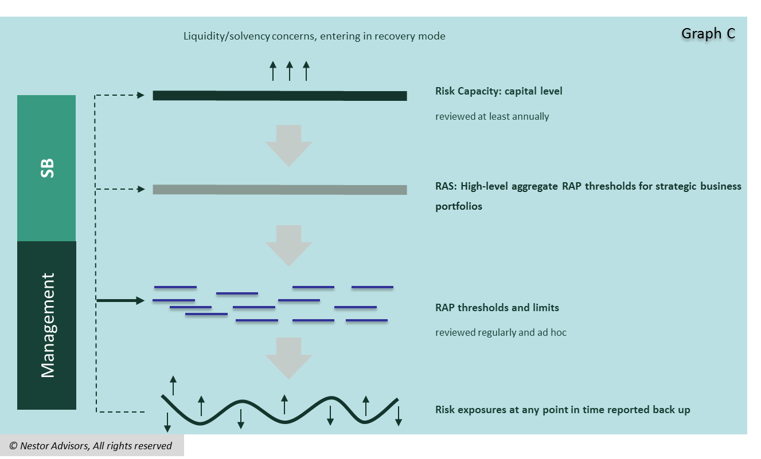
- Setting the risk capacity, the RAS category levels as well as the RAF’s system of thresholds and limits relies on stress testing at the institution-wide level but also at lower levels as required. It is worth noting that banks can, and where possible should, combine stress testing for ICAAP/ILAAP purposes as well as scenario planning for recovery purposes with stressing required for RAF purposes.
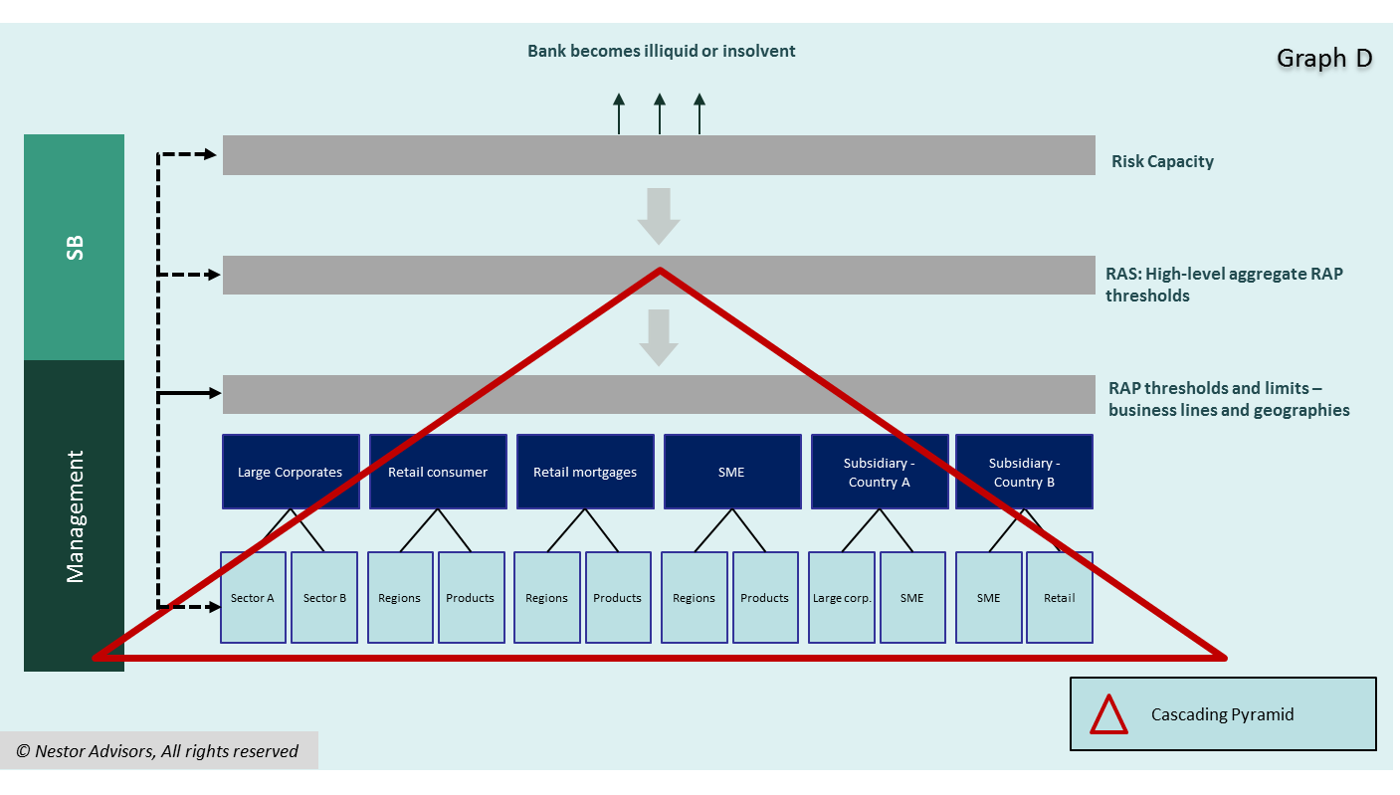
    - Risk Categories and Comprehensiveness of the RAF
      - Guidelines
15. The bank needs to ensure the RAS is comprehensive in scope and captures all material financial and non-financial risks that the bank is exposed to through the full range of its activities and business lines.
16. In order to achieve comprehensiveness, the bank should complement the ICAAP/ILAAP risk identification and measurement exercise with an additional toolkit of RAF related metrics.
      - Discussion
- A well-developed RAF should be comprehensive in scope and cover all material risks to the specific bank. As discussed above, the bank will have gone through an extensive risk identification/mapping exercise in the key risk areas of the Basel “risk canon”. This exercise is very relevant to the development of the RAS but it is not sufficient. Many business areas will require specific metrics in order to effectively limit the amount of risk that is assumed or tolerated by the bank in the RAP context.
- In view of this two-pronged approach, the RAF can be conceived as a matrix that, on the one hand, accounts for the bank’s material risk categories identified as part of ICAAP, and, on the other, links risk to the bank’s business plan and budget for different business areas and activities. An example of such a matrix is shown in graph E below.
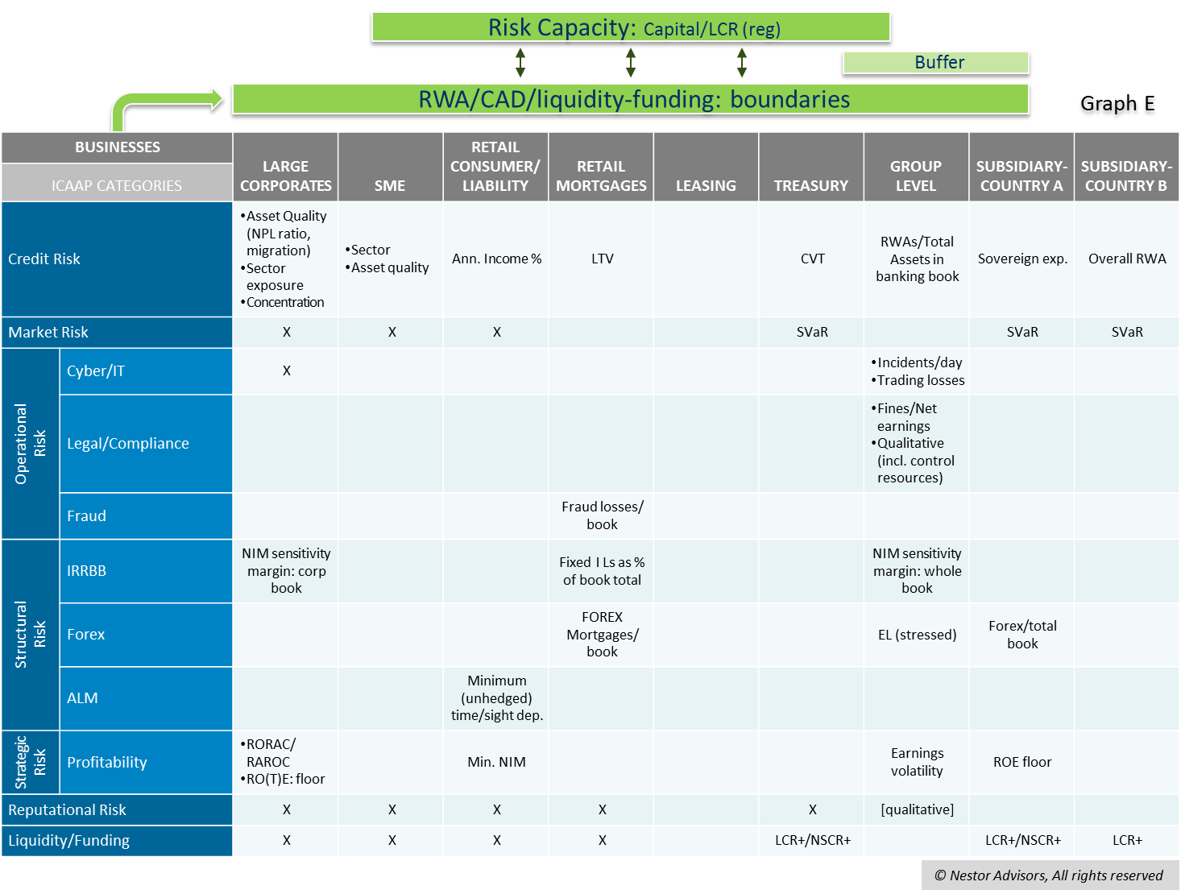
- Banks often find it challenging to capture material non-financial risks such as compliance, reputational, legal, and conduct risks. It may indeed be a challenge to quantify these risks, so the ECB and the FSB accept that banks may address non-financial risks in their RAFs in a qualitative way - as long as the qualitative statements are specific enough.
- While quantifying operational risk can prove challenging, there are ways that more complex banks can establish “proxy approaches” that would allow them to quantify their operational risk tolerances. First and foremost, these would include a methodology for tracking historic losses associated with different types of operational risk. Banks can also track “near misses”, i.e. risk events that did not lead to actual losses but came close to doing so. Based on these past experiences, banks can then establish certain maximum loss amounts that they are willing to accept in the course of their business. Insurance may also be used to cap these losses.
- Similar approaches could be employed for other types of non-financial risk, such as reputational risk. The nature of reputational risk as a secondary (or second-impact) risk can render difficult its inclusion in the RAF in a quantitative way.
Case Box 4
Bank D established the following limit in its RAF: we will not tolerate total annual fraud losses across the bank higher than EUR 500,000. This figure represents a 20% reduction relative to the average annual fraud losses over the past 3 years. To minimise fraud losses the bank has also committed to an overhaul of its online banking system and increased the headcount in its fraud prevention unit by 5%.
The limit allows the bank to effectively include specific areas of operational risks into the RAF. The accompanying measures to limit fraud losses provide further detail on how the bank intends to keep losses within the limit. These commitments must convincingly support the reduction in fraud losses relative to the past 3 years. The bank should also consider tracking over time not only loss events but also the number and frequency of near misses.

    - RAP Metrics and Proportionality
- The discussion of RAF metrics above raises important proportionality issues.
- Larger and more complex banks can be expected to calculate their risk capacity based on internal capital calculations and/or Pillar 2 capital requirements. Smaller banks often rely on Pillar 1 when calculating their capital requirements and might therefore also focus on this approach when calculating their risk capacity. It is also important to note however, that a bank’s approach in calculating capital requirements is often determined by the competent supervisor: if the supervisor sets a Pillar 2 add-on capital requirement for a smaller bank as a result of the SREP, the bank can also be expected to use the approach under Pillar 2 to calculate its risk capacity. In other words, smaller banks may choose to stick to regulatory capital metrics unless the supervisor concretely expects otherwise.
- Many smaller banks might find it challenging to capture material non-financial risks in their RAFs. It should therefore be noted that the ECB and the FSB accept that banks may address non-financial risks in a purely qualitative way. We believe that this will make it easier for smaller, less complex banks to design comprehensive RAFs. However, they should keep in mind that these qualitative statements must be specific enough to be challenged and benchmarked internally and externally.
  - Embedding and Cascading
    - Cascading and Escalation
      - Guidelines
17. RAP limits and thresholds should be meaningful at every level. They should constitute actual constraints on business decisions and risk taking across the bank’s businesses and activities.
18. The bank needs to establish clear escalation procedures regarding both RAP thresholds and RAP limits.
19. The SBRC needs to have early warning triggers built into the RAS dashboard for all the RAS categories (“buckets”).
      - Discussion
- Well-developed RAFs include a set of RAP metrics, thresholds, and limits. As discussed above under I. C., RAP thresholds set the level of RAP the bank wants to assume with respect to a given aggregation of assets (portfolio), and RAP limits set the level of RAP either for a given (often relatively small) portfolio or for specific transactions. RAP being a top-down process, all RAP thresholds and limits are cascaded down from the top-level RAS metrics.
- Importantly, thresholds and limits differ with respect to the consequences of a breach. The breach of a limit is a hard constraint on business approvals; when a threshold is breached, this merely requires reporting to a higher instance in the bank (“raising the flag”).
Case Box 5
Bank E sets a RAP threshold for the whole of the mortgage portfolio of a retail business at 75% loan-to-value (LTV) ratio. As this is cascaded further down the organisation, mortgages for some specific regions (domestic branches or foreign entities) are set at different LTV levels.
Appropriate RAP limits are then established for the respective product segments, e.g. an operational RAP limit for individual mortgages in city X at 90% LTV ratio (transaction limit). This means that individual transactions cannot be agreed at higher LTV levels without proper escalation.

- RAP limits are only effective in steering risk taking across the bank, if they are designed as real and meaningful constraints on business decisions. This means that limits need to be close enough to the actual (or potential) risk profile of a given business unit. A risk profile that is too far within the RAP perimeter (see graph B below for an illustration of the concepts involved) might actually indicate that the bank is taking far too few risks and that therefore it might be undermining its long-term profitability and hence its soundness and sustainability.

Case Box 6
Bank F is using RoTE as a metric of profitability risk (or soundness). However, in the proposed RAS the respective RAP threshold is set is the same level as the RoE target of the business plan (10%).
The Chair of the SBRC argues that, while she understands that the RoTE can serve as a useful metric for the bank’s on-going profitability, what she really wants to see in the RAS is a lower RoTE value, below which the bank’s business is not sustainable. She argues that this is a target that needs to be met consistently across the bank’s portfolio.
There might actually be a need to set such minimum RoTE thresholds specifically for the trade finance business of the bank, which has been consistently underperforming in recent years. The SBRC would like to see early warning signs if these performance thresholds are not met.

- RAFs need to establish clear procedures for what happens when a threshold or a limit is breached. This includes the designation of escalation authorities, timelines and potential remedial actions.
- Escalation procedures should therefore define the roles of various stakeholders: the responsible business units, the risk management function, senior management and its management committees (e.g. the management risk committee, the ALCO/capital committee or specific product committees) and, regarding higher RAS levels, the MgmtB, the SBRC, and the SB.
- Escalation in the case of limit breaches will depend on strictly defined escalation procedures and will almost always include the risk management function at a senior level.
- Regarding the breach of portfolio thresholds, there is no immediate constraint on individual transactions when a threshold is reached. Escalation consists of “raising the flag” to senior management and, as required, the SBRC and the SB. However, the reporting of a threshold breach should lead to remedial action, which might consist of raising the limits for the particular product/credit category (please see the example of Bank F in Case Box 6 above). Also, it is important for banks to document the causes of threshold breaches and the rationale behind any remedial action taken as a result.
- It should also be noted that the bank’s leadership, including the SB and MgmtB, need to be aware of how the lower level escalation procedures are structured, in order to be able to monitor the application of the whole RAF throughout the bank.
- Regarding the monitoring of potential breaches, international supervisors emphasise the essential role of an effective MIS.
“An effective and efficient RAF should be closely linked to the development of information technology (IT) and management information systems (MIS) in financial institutions.”
- FSB Principles for An Effective Risk Appetite Framework
- In addition to the RAP thresholds and limits set out above, banks should also focus on early warning triggers, set at lower levels than those of a threshold, so that senior management and, as required, the SBRC have ample time to reflect upon remedial action and the adjustment of the business plan.
- A related matter that has received increasing attention from supervisors is the consideration of RAF metrics when launching new banking products. Banks need to measure the risk sensitivity of new services and consider the impact on their overall risk profile. Generally speaking, each product delivered to each customer segment should have its own risk appetite set on an ex ante basis.
    - Embedding: Communication, Training, and Risk Culture
      - Recommendations
20. The bank should actively engage with its staff on RAP related issues, while respecting confidentiality of certain RAS thresholds.
21. Business units should be trained on the RAF, its implementation and functioning.
      - Detailed Guidance
- For the RAF to become an effective part of a bank’s overall strategy and risk management, the bank needs to foster a mind-set and culture of risk awareness and challenge. To this end, the RAF’s importance and goals must be actively communicated to all relevant stakeholders across the bank:
“Financial institutions that implement a RAF most effectively are those that (…) communicate and promote the framework throughout the organisation, starting from the top.”
- FSB Principles for An Effective Risk Appetite Framework
“The institution should have in place a process of communication with its employees in order to explain to them how their job affects the risk appetite of the bank.”
- SSM Supervisory Statement
- Actively engaging with employees on RAP issues enables management to develop their understanding of the RAF and to foster risk awareness. It also helps develop and steer an organisation’s risk culture through the definition of a common language and common attitudes related to RAP. Both the FSB and the SSM explicitly recognise the important role of an effective RAF in promoting a strong risk culture:

“Establishing an effective RAF helps to reinforce a strong risk culture at financial institutions, which in turn is critical to sound risk management. A sound risk culture will provide an environment that is conducive to ensuring that emerging risks that will have material impact on an institution, and any risk-taking activities beyond the institution’s risk appetite, are recognised, escalated, and addressed in a timely manner.”
- FSB Principles for An Effective Risk Appetite Framework
- Banks should develop training programmes on RAP and the way in which the RAF works across the group, both for risk specialists and lines of business. We believe that this can go a long way towards embedding the RAF within the organisation and facilitating buy-in from business units that are directly affected by the RAP limit system. It is also important for banks to communicate explicitly to the managers of individual business units or entities how RAFs will impact their daily decision making.
- Trainings and other forms of embedding activities such as employee surveys on particular RAP aspects (e.g. compliance risk and the controls build around it) also allow management to solicit bottom-up inputs that can be used in reviewing the adequacy of existing RAF thresholds and limits.
- It should also be noted that there need to be certain restrictions regarding the communication of the RAF and RAS across the bank. Conducting training on the usage of RAFs as outlined above does not mean that the RAS, which contains very sensitive strategic information, needs to be fully disclosed and communicated in detail to all staff members. Banks need to be mindful of the confidentiality of certain RAS elements, especially regarding the high-level RAP thresholds. The information communicated to business lines and units should be granular enough to allow for effective usage of the RAF, while respecting the need for confidentiality that is required in certain RAS areas.
Case Box 7
Under the initiative of the CRO, the risk management function of Bank G has presented the institution-wide RAS (the first of its kind) to a wider audience of employees, including senior management, middle office units, and specific sectors teams. These sessions were designed to facilitate the usage of the RAF throughout the bank. This was viewed by the MgmtB and the SB to have been a very good initiative.
However, the Chair of the SB raised a point that caused second thoughts in the SBRC. She argued that the reason that such a comprehensive presentation of the RAS was able to occur was because the RAS was not granular enough and did not raise specific issues related to the business plan and budget of the bank. It was resolved that the SBRC would review the RAS to make it more relevant to the business and would guide the CRO to (a) make a general presentation of the RAF and general nature of the RAS and (b) develop more granular presentations to smaller groups focusing on more topical/granular RAS aspects.

    - Embedding: Remuneration
      - Recommendations
22. The bank should explicitly link variable remuneration to respecting applicable RAP thresholds and limits. This link should be reflected in the bank’s remuneration policies.
      - Detailed Guidance
- Another important aspect related to the embedding of RAFs is staff remuneration. The ECB has issued initial guidance in this area, but this topic was not elaborated in much detail in the SSM Supervisory Statement. According to ECB guidance, the RAF should be closely linked to banks’ remuneration frameworks. Variable staff remuneration should be linked to some risk factors in line with Article 94 CRD IV, both ex ante (key risk-related performance indicators used as an input to calculate variable remuneration) and ex post (“malus” provisions in the event of non-compliance with key risk indicators).
- The link between the RAF and the remuneration framework should cover two aspects. Firstly, staying within RAP thresholds for the businesses that they are responsible for should be one of the factors in setting the variable remuneration of senior executives. Secondly, a malus could kick in if the risk profile was underestimated or underreported in a period and this becomes evident ex post.
    - External Communication
      - Recommendations
23. The bank should make an effort to improve Pillar 3 disclosures as regards the description of its RAF, the structure of its RAS, and the main elements of risk profile reporting.
      - Detailed Guidance
- The level of information disclosed in Annual Reports and Pillar 3 Reports differs widely among Slovenian banks. While the CRD IV framework does not mandate detailed RAP-related disclosures, more could be done to improve transparency. This would allow for a better understanding of each bank’s RAP-related and risk governance practices by the financial marketplace. Furthermore, transparency is also a powerful incentive for other banks to bring their practices up to standard.
- While they should not disclose the entire RAS, banks should generally disclose information on the goals of their RAFs and the role of the different bodies and units involved in preparing and approving the RAF.
- The information can be presented in brief, general terms, but disclosures should cover the link between the RAF and business strategy, the different steps in preparing the RAF, plus the role of internal bodies such as the SB, the SBRC, the MgmtB, senior management, and the risk management function. The following example illustrates this approach:
“The Group's risk appetite framework, approved by the Board, determines the risks (and their level) that the Group is willing to assume to achieve its business objectives considering an organic evolution of its business. These are expressed in terms of solvency, liquidity and funding profitability, recurrent earnings, cost of risk or other metrics, which are reviewed periodically as well as in case of material changes to the entity’s business or relevant corporate transactions.”
- A sample bank
- When it comes to RAP metrics, banks could disclose general categories used to link their businesses to the institution-wide risk profile, their overall approach to setting their risk capacity and their philosophy behind the typology of risks they employ. However, the disclosure of individual numerical targets would not be expected. This can be illustrated by the following partial example, based on the public disclosures of a sample bank:
Volatility of results | Solvency | Liquidity | Concentration | Non-financial and transversal risks
- Maximum loss the Group is prepared to accept under a scenario of acute tension | - Minimum capital position the Group is prepared to accept under a scenario of acute tension  - Maximum leverage the Group is prepared to accept under a scenario of acute tension | - Minimum structural liquidity position  - Minimum liquidity horizon position that the Group is prepared to accept under a scenario of acute tension  - Minimum liquidity coverage position | - Concentration by individual customer  - Concentration in non-investment grade counterparties  - Concentration in large exposures | - Qualitative operational risk indicators: Fraud; Technological; Security and cyber-risk; Litigation; Other  - Maximum operational risk losses  - Maximum risk profile
- Briefly describing how banks embed their RAPs within the organisation as discussed above might also be considered best practice. Banks should also consider disclosing information on how they link their RAFs and remuneration frameworks:
“The remuneration program was also directly linked to the Group RAS to reinforce risk culture and risk awareness within the Group. In that light, the determination of the annual bonus pool must consider if the relevant core metrics are within the Group RAS.”
- A sample bank
    - Embedding of the RAF and Proportionality
- For reasons of proportionality, embedding the RAF should involve different steps depending on the size and complexity of the bank.
- As per the discussion above, banks should develop training programmes on RAP and the way that the RAF works within the group. Smaller banks can also be expected to undertake certain internal outreach and training efforts. Especially if training sessions are targeted to the most important internal stakeholders and confidential strategic information is only used where appropriate, there is no reason why smaller organisations should not facilitate the embedding of their RAFs through training. For less complex banks, the development of courses including exams and certification by the Bank Association of Slovenia might be another important way of enhancing RAP “consciousness” and the broader risk culture of the institution.
- It is understandable that smaller banks may not have the capacity to produce extensive, best practice disclosures related to their RAP within the generally permissive confines of the CRD IV framework. It might be sufficient for such banks to simply mention that they have developed a RAF and a RAS that are approved by the SB and reviewed on a regular basis.

- E N D -

Article 3 (1) (7) of Directive 2013/36/EU.
ECB, SSM Supervisory Statement on Governance and Risk Appetite, June 2016, p 2.
EBA, Final Report - Guidelines on internal governance under Directive 2013/36/EU, EBA/GL/2017/11, 26 September 2017, p 8.
This also covers the Board of Directors in its supervisory capacity under the unitary board system. In particular, well developed RAFs should provide a mechanism to engage non-executive members of the unitary Board of Directors in developing a risk-conscious strategy and in capital planning and allocation.
FSB, Principles for An Effective Risk Appetite Framework, 2013.
Directive 2013/36/EU and Regulation (EU) No 575/2013.
It is important to note that banks might use different terms for the concepts of RAP thresholds and limits defined in the body of the text, depending on specific institutional legacies. This should not obscure the difference between these two concepts. Please also see the discussion under II. C. i. for further details.
Please note that the following is a high-level summary and that the sequencing of the different steps should be adapted based on the particular circumstances and processes of the given institution.
The EU Bank Recovery and Resolution Directive. Please refer to our discussion under II. C. i. for more details.
Under CRD IV rules, institutions that are not deemed to be significant under the SSM framework do not have to establish a separate SBRC. According to Article 49 (2) of the Slovenian Banking Act of 2015, banks can request permission from the BoS to establish a combined audit and risk committee. Regarding the bank’s risks, this combined committee has to perform the same tasks as a separate SBRC.
According to Article 7, paragraph 1, item 30 of the Slovenian Banking Act of 2015, the term "senior management" refers to the management level just below the Management Board (B-1).
SSM Supervisory Statement, p 19. In practice, the compliance function might also provide some input at specific stages of the RAF development.
Please see Graph E under II. B. iii. for some examples of risk indicators.
For more details please see under II. C. i. below.
Please see our discussion of the merged committee under II. A. i. above.
See the definition of RAP thresholds and limits under I. C. above.
The ICAAP/ILAAP system also includes forward-looking elements such as stress testing and capital planning. However, it is always anchored on the current risk profile, not on the bank’s strategic objectives. The RAP framework reflects and is calibrated on the latter rather than the former.
EBA, Guidelines on the Range of Scenarios to be Used in Recovery Plans, 2014, p 8.
Co-ordination in planning does not mean identical triggers/thresholds. Typically, the recovery triggers would be stricter than the risk capacity thresholds. Please also see the discussion below in paragraphs 55-60.
Alternatively, this could also be calculated in loss amounts.
For further details please see our discussion under Section II. B. iii.
FSB, Principles for An Effective Risk Appetite Framework, 2013, p 6; SSM Supervisory Statement, p 16.
SSM Supervisory Statement, p 16.
FSB, Principles for An Effective Risk Appetite Framework, 2013, p 6, footnote no 9.
Reputational risk is defined as the additional negative economic impact that you might have in terms of business loss/foregone profits because of reduced trust in the firm’s integrity and competence due to the materialisation of another risk.
SSM Supervisory Statement, p 16.
FSB, Principles for An Effective Risk Appetite Framework, 2013, p 6, footnote no 9.
FSB, Principles for An Effective Risk Appetite Framework; p 4. SSM Supervisory Statement, p 17.
SSM Supervisory Statement, p 17. The ECB uses a slightly different terminology here (“early warning thresholds”). For the sake of clarity and to differentiate these additional boundaries from the RAP thresholds referenced above in the text, we will refer to them as early warning triggers.
FSB, Principles for An Effective Risk Appetite Framework, p 1.
SSM Supervisory Statement, p 17.
Directive 2013/36/EU.
SSM Supervisory Statement, p 18.

